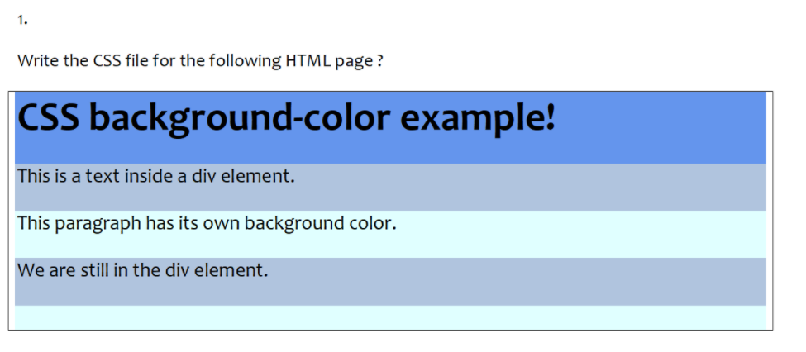

<!DOCTYPE html>

<html>

<head>

<style>

h1 {

background-color: #2166a3;

}

div {

background-color: lightgrey;

}

p {

background-color: lightblue;

}

</style>

</head>

<body>

<h1>CSS background-color example!</h1>

<div>

This is a text inside a div element.

<p>This paragraph has its own background color.</p>

We are still in the div element.

</div>

</body>

</html>

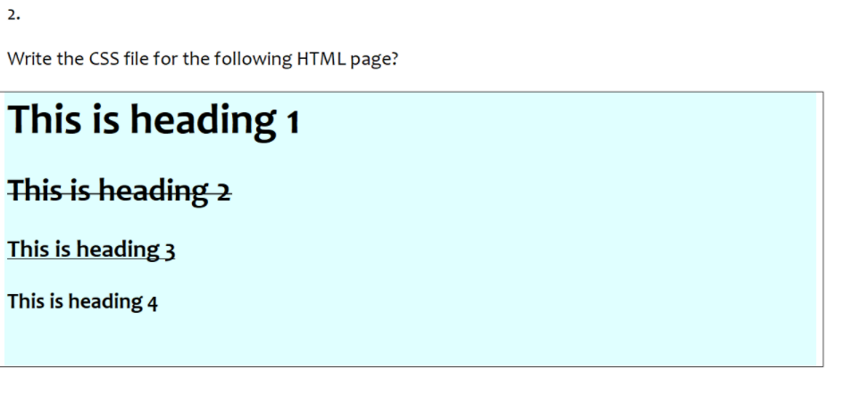

<!DOCTYPE html>

<html>

<head>

<style>

body{

background-color: skyblue;

}

h2 {

text-decoration: line-through;

}

h3 {

text-decoration: underline;

}

</style>

</head>

<body>

<h1>This is heading 1</h1>

<h2>This is heading 2</h2>

<h3>This is heading 3</h3>

<h4>This is heading 4</h4>

</body>

</html>

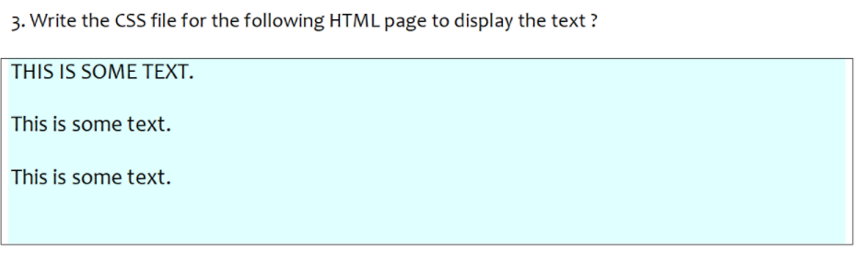

<!DOCTYPE html>

<html>

<head>

<style>

body {

background-color: skyblue;

}

</style>

</head>

<body>

<h4>THIS IS SOME TEXT.</h4>

<p>This is some text.</p>

<p>This is some text.</p>

</body>

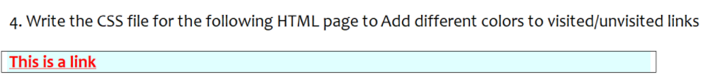

<head>

<style>

/* unvisited link */

a:link {

color: red;

}

/* visited link */

a:visited {

color: green;

}

/* selected link */

a:active {

color: blue;

}

</style>

</head>

<body>

<p><b><a href="default.asp" target="_blank">This is a link</a></b></p>

</body>

</html>

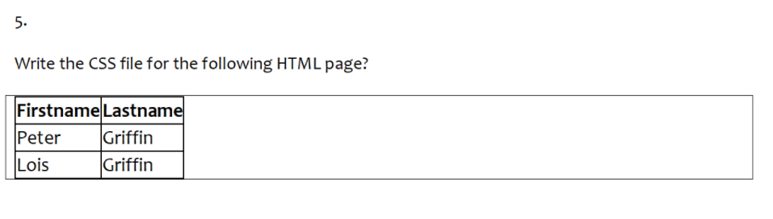

<!DOCTYPE html>

<html>

<head>

<style>

table, td, th {

border: 1px solid black;

}

table {

border-collapse: collapse;

}

</style>

</head>

<body>

<table>

<tr>

<th>Firstname</th>

<th>Lastname</th>

</tr>

<tr>

<td>Peter</td>

<td>Griffin</td>

</tr>

<tr>

<td>Lois</td>

<td>Griffin</td>

</tr>

</table>

</body>

</html>

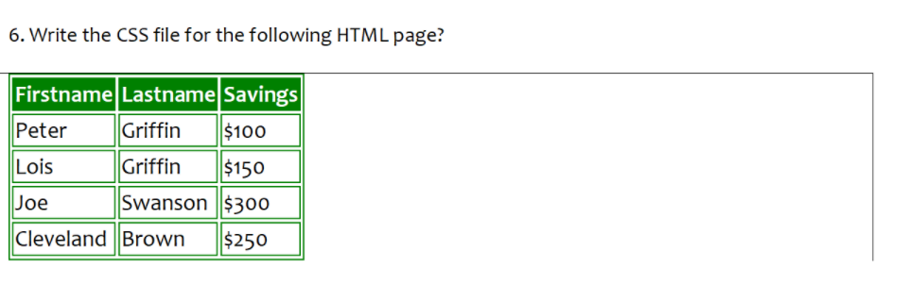

<!DOCTYPE html>

<html>

<head>

<style>

table, th, td {

border: 2px solid black;

border-color:green;

}

</style>

</head>

<body>

<table>

<tr bgcolor="green;">

<th>Firstname</th>

<th>Lastname</th>

<th>Savings</th>

</tr>

<tr>

<td>Peter</td>

<td>Griffin</td>

<td>$100</td>

</tr>

<tr>

<td>Lois</td>

<td>Griffin</td>

<td>$150</td>

</tr>

<tr>

<td>Joe</td>

<td>Swanson</td>

<td>$300</td>

</tr>

<tr>

<td>Cleveland</td>

<td>Brown</td>

<td>$250</td>

</tr>

</table>

</body>

</html>

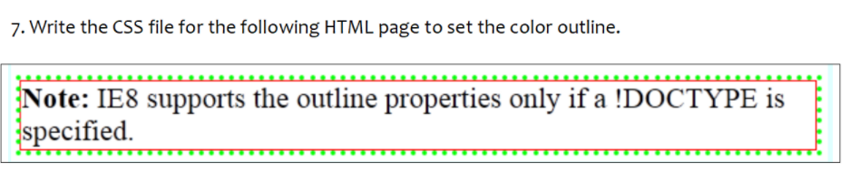

<!DOCTYPE html>

<html>

<head>

<style>

p.dotted {

border-style: dotted;

border-color: green;

}

div {

border: 1px solid red;

}

</style>

</head>

<body>

<div>

<p class="dotted"><b>Note:</b>IE8 supports the outline properties only if a !DOCTYPE as specified.</p>

</div>

</body>

</html>

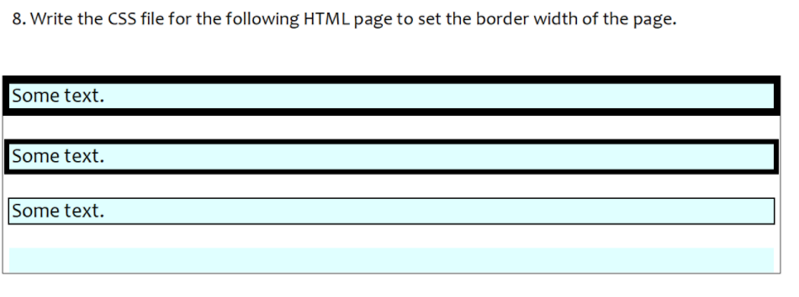

<!DOCTYPE html>

<html>

<head>

<style>

p{

background-color:skyblue;

}

p.one {

border-style: solid;

border-width: 5px;

}

p.two {

border-style: solid;

border-width: medium;

}

p.three {

border-style: solid;

border-width: 1px;

}

</style>

</head>

<body>

<p class="one">Some text.</p>

<p class="two">Some text.</p>

<p class="three">Some text.</p>

</body>

</html>